6TH GRADE Name__________________________ Date___________________________
6TH UNIT 4 CHART
Word + Other Forms  (parts of speech) | Connotation  (positive or negative) | Structure  (prefix, suffix and root meaning) | Original Sentence  (use your brain) | Mnemonic or Visual
Acquit  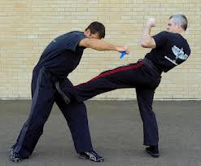 |  |  |  | 
Deem |  |  |  | 
Devastate |  |  |  | 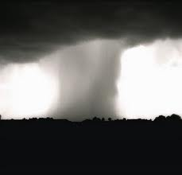
Discredit |  |  |  | 
Elusive |  |  |  | 
Generate |  |  |  | 
Idolize |  |  |  | 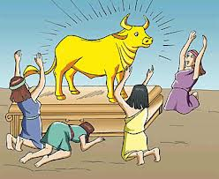

Ingratitude |  |  |  | 
Keepsake |  |  |  | 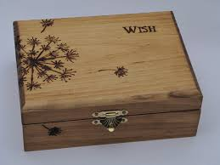
Mortal |  |  |  | 

Ovation |  |  |  | 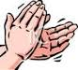

Petty |  |  |  | 
Plight |  |  |  | 

Repent |  |  |  | 
Reverie |  |  |  | 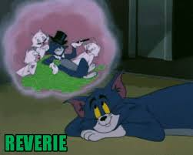

Strands |  |  |  | 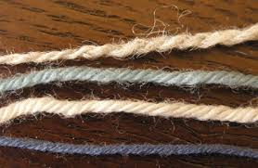
Strife |  |  |  | 

Topple |  |  |  | 

